**Non-Deere Computer**:

**Prior to setup:**

Before connecting and logging in for the first time, you will need the following:

1. A John Deere User ID & Password.

o If you do not have this, please contact the Global IT Service Desk or your Deere sponsor.

1. A computer with an internet connection
2. Okta Multi-Factor Authentication (MFA) configured.

o Navigate to <https://johndeere.okta.com> and complete the registration

o When selecting the verification method, please use one of the following

1. Okta Verify Mobile App

2. SMS Authentication

3. Voice Call Authentication

4. Yubikey

o If you have any questions or receive an error setting up Okta, please contact the Global IT S ervice Desk or your Deere sponsor.

**Setup**:

Go to <https://clients.amazonworkspaces.com>

Hover your mouse over the type of computer you have and then click “**Download**”

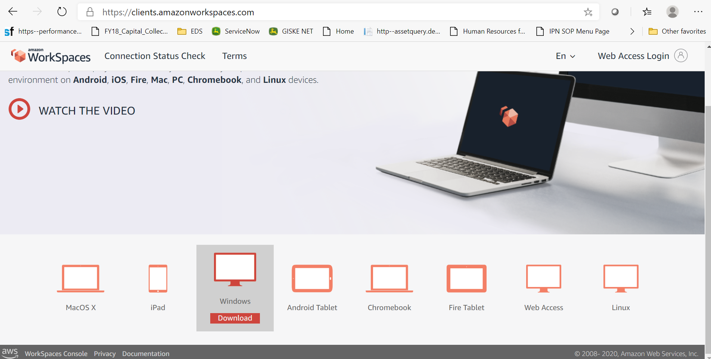

Depending on your browser, you will see an icon appear to show the files are downloading, once complete click “Open” or “Open File”

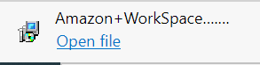

Click “Next” to begin the AWS installation:

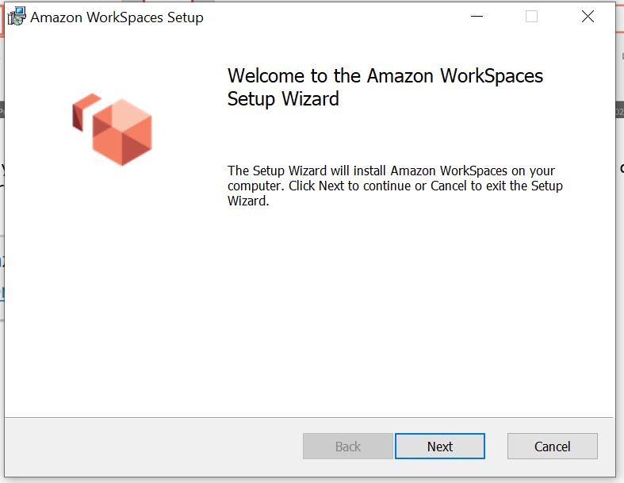

Click “Next” two more times:

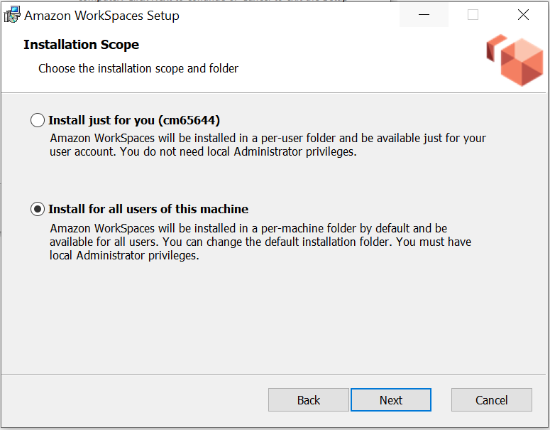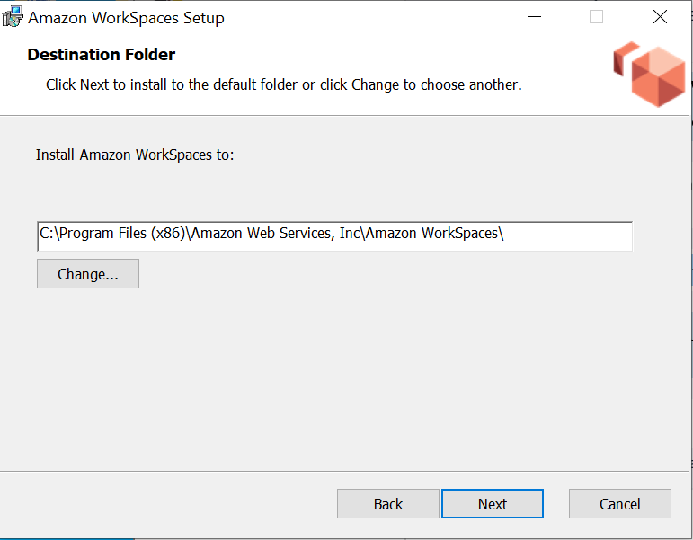

Click “Install”

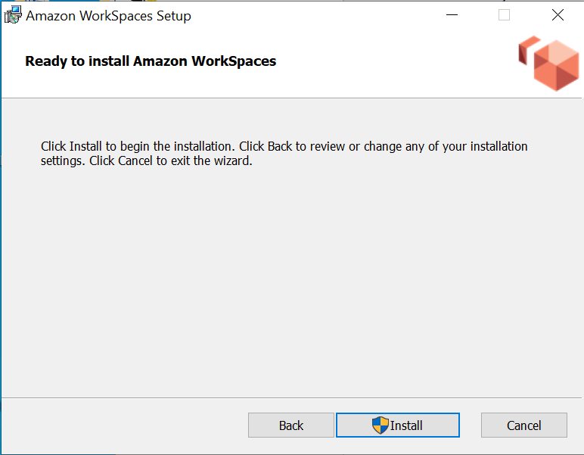

Click “Finish”

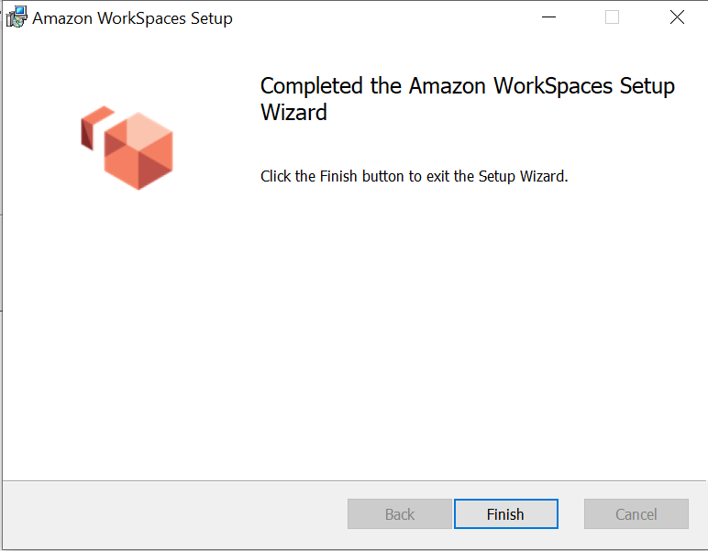

On your desktop, you should now see the AWS icon. Click it twice to open it.

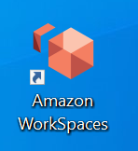

Enter the registration key that was provided to you.

If you did not receive a registration key, contact the Global IT Service Desk or your Deere sponsor

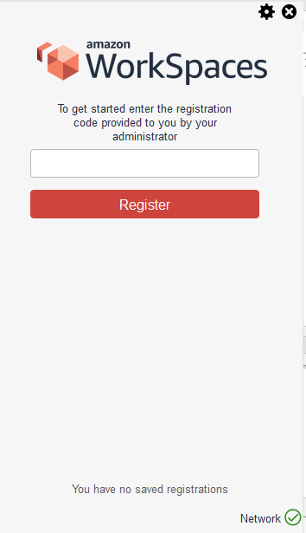

You should now see the login page:

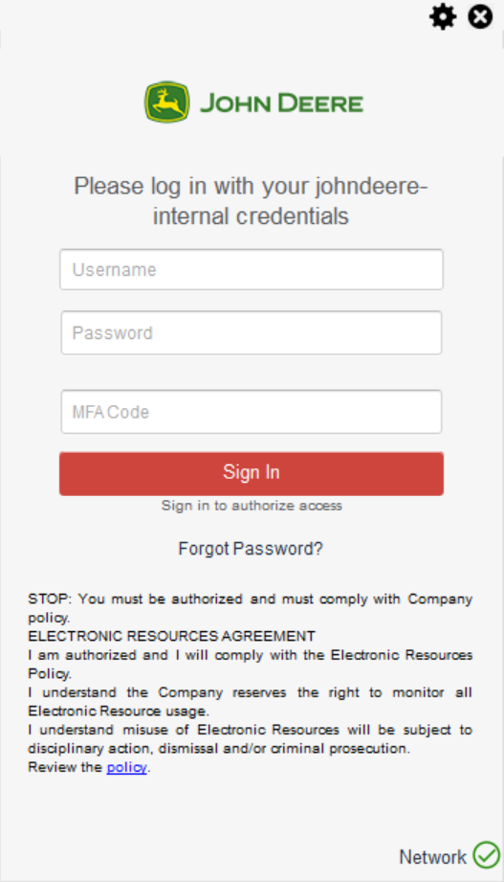

a. Enter your John Deere UserID in the “Username” field

b. Enter your John Deere password in the “Password” field.

c. Use the “MFA Code” field to enter the Okta method you setup from above.

i. Put in the Okta verification code from the Okta Verify application

ii. Type in sms in the MFA field and click on Sign In to receive the authentication code via SMS in your verified mobile number.

iii. Type in call in the MFA field and click on Sign In to receive the authentication code over voice call in your verified mobile number.

iv. Place the cursor in the MFA field and plug in the Yubikey for the code to reflect automatically in the MFA field.

**RDP Configuration**:

Once your AWS session opens, Right Mouse click on the AWS desktop and click “Shortcut”

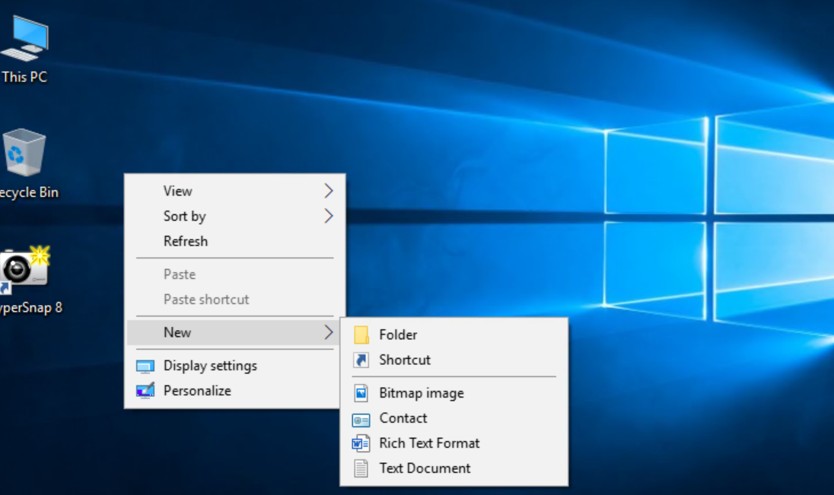

In the shortcut window type in “MSTSC”

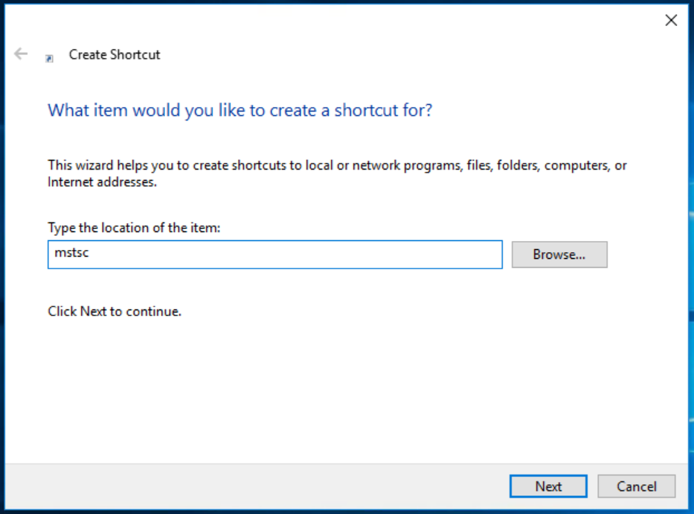

This will create a Remote Desktop Icon on the AWS desktop. Double Click the icon to open it:

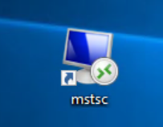

Once open, type the remote computer name you want to connect to and click “Connect”

1. If you do not know your computer name go to <http://assetquery.deere.com/en/#/Hardware/UserId> from a Deere PC and type in your userid to show all of the assets that are owned by you. The “Name” section of “Computer Details” will be the computer name.

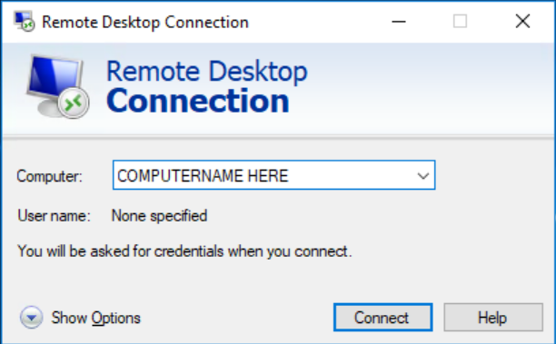

This will now open a connection to your PC located within the Deere facility.

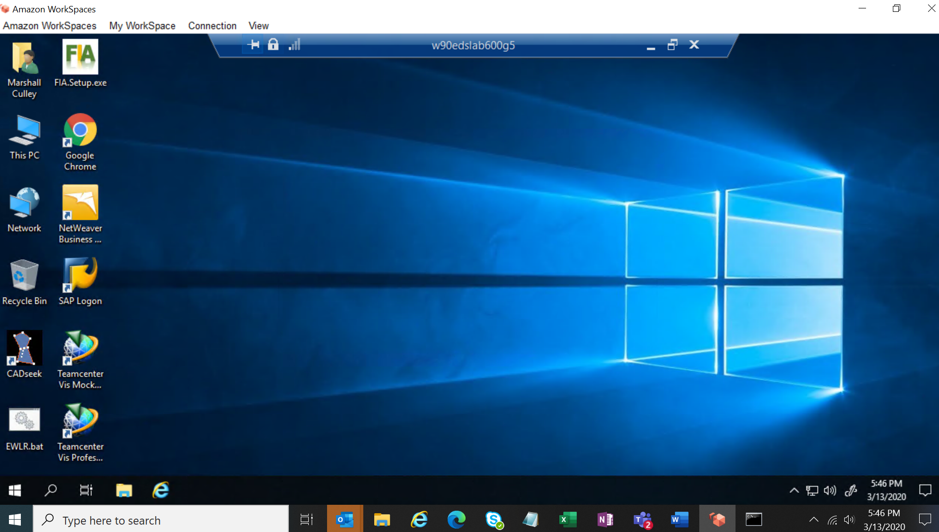

**Best practices for RDP use**:

* You can freely resize the RDP window.
* Clicking the “X” in the corner will close your RDP session, while leaving all applications running
* You can sign out (puts machine back to login screen) or restart the desktop. These options will require you to log back into the machine through RDP.

**Do not** click “shutdown” or “sleep” in your RDP session. This will make the machine you are connected to inaccessible. This will require someone to go onsite to turn the device back on manually.

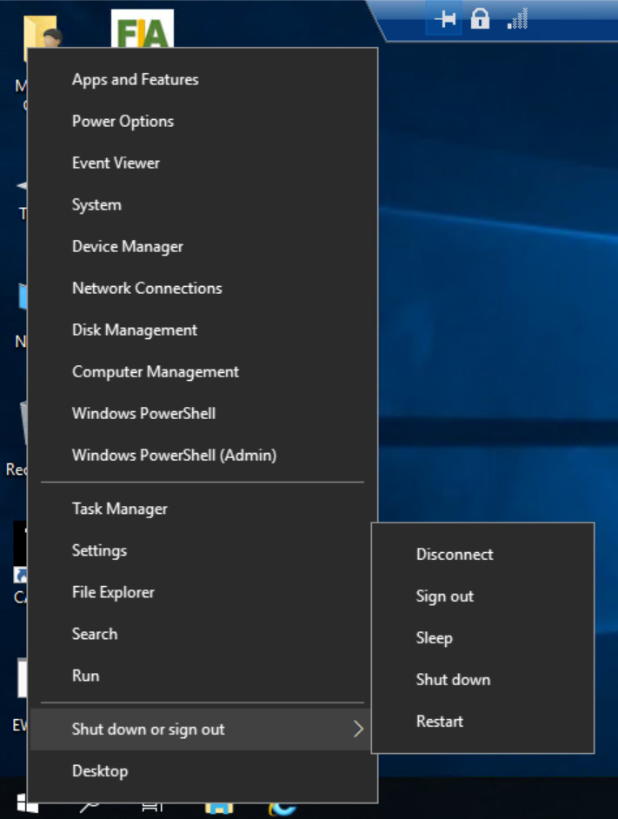

**NOTE**: While you are in the RDP session, the monitor attached to the remote PC automatically goes blank.

**Best practices for VDI use**:

Do not save critical data on your AWS Workspace. Please talk with your Deere contact to request network or SharePoint storage.

If you need to install software in your Workspace, please utilize <http://jdsrs.deere.com> .

o If the software that you need is not in JDSRS, please use the "Software not currently in the system" request. When prompted to reboot for Windows patches or updates, please use the prompt to reboot the session.

To send a "Control + Alt + Delete" to the session, from the "Connection" menu, select "Send CTRL-ALT-DEL"